**ATM MANAGEMENT SYSTEM**

**By**

**Shrimoyee Banerjee- 17BCE118**

**Dinesh Solanki – 16BCE088**



**DEPARTMENT OF COMPUTER SCIENCE & ENGINEERING**

**Ahmedabad 382481**

**ATM MANAGEMENT SYSTEM**

**Mini Project – I**

Submitted in partial fulfillment of the requirements

For the degree of

**Bachelor of Technology in Computer Engineering/Information Technology**

By

**Shrimoyee Banerjee – 17BCE118**

**& Dinesh Solanki – 16BCE088**

Guided By

**Prof. Ajay Patel**

**[DEPARTMENT OF COMPUTER SCIENCE & ENGINEERING]**



**DEPARTMENT OF COMPUTER SCIENCE & ENGINEERING**

**Ahmedabad 382481**

**CERTIFICATE**

This is to certify that the Mini Project -I entitled “ATM MANAGEMENT SYSTEM” submitted by Shrimoyee Banerjee (17BCE118) and Dinesh Solanki (16BCE088), towards the partial fulfillment of the requirements for the degree of Bachelor of Technology inInformation Technology/Computer Engineering of Nirma University is the record of work carried out by him/her under my supervision and guidance. In my opinion, the submitted work has reached a level required for being accepted for examination.

Prof. Ajay Patel Dr. Madhuri Bhavsar (HOD)

Assistant Professor Dept. of Computer Science & Engineering,

Department of Computer Science & Engg., Institute of Technology,

Institute of Technology, Nirma University,

Nirma University, Ahmedabad

Ahmedabad

**ACKNOWLEDGEMENT**

We would like to express our deepest appreciation to all those who provided us

the possibility to complete this report. We acknowledge with thanks, the support

rendered by Prof. Ajaykumar Patel, under whose guidance we were able to

complete the task in a given period of time. This report could not be complete

without coordination of the team members Shrimoyee Banerjee and Dinesh Solanki. We also appreciate the constructive suggestions given by our friends to further enhance content of the report.

**ABSTRACT/ Outline**

This program aims to facilitate the process of ATM banking system that we use on our day to day life. We’ve tried to include all the basic functionalities required in the atm management system that makes easier for the person to use the system.

**We aim to have the following use cases in the program:**

1. Starts the program by asking the user his/her pin.
2. **Deposit Money**: asks the user whether he/she wants to deposit the amount in the savings or current account and then the amount.
3. **Withdraw Money**: same way asks the user from which account and asks for the amount.
4. **Transfer Funds**: from saving to current or vice versa.
5. **Check Account Balance**: displays the account balance present.
6. **Change Pin**: asks to enter the old pin and the new pin. After re-entering the new pin it is changed successfully.
7. **End Session**: session ends and displays “have a nice day.”

**CONTENTS**

Certificate

Acknowledgement

Abstract

Contents

**List Of Figures:**

Fig. 2.1- Use Case diagram of the program

Fig. 2.2 – Class diagram of the program

Fig. 2.3- Sequence diagram of the program

Fig.3.1- Screenshot of functionality 1 of entering pin

Fig.3.2- Screenshot of Deposit money

Fig.3.3- Screenshot of Withdraw money

Fig.3.4- Screenshot of Transfer Funds

Fig.3.5- Screenshot of checking account balance

Fig.3.6- Screenshot of changing pin

Fig.3.7- Screenshot of Ending the session

**Chapter 1 Introduction 1**

1.1 General 1

1.2 Objective of study 1

**Chapter 2 Preliminary Designs**

2.1 Use case diagram 2

2.2 Class diagram 3

2.3 Sequence diagram 5

**Chapter 3**

**Fuctionalities in detail 6**

**Chapter F Summary and Conclusion 13**

F.1 Summary

F.2 Conclusions

**(F stands for no. of final chapter)**

**References**

**References should not be like** [**www.wikipedia.com**](http://www.wikipedia.com) **or www.google.com . it should include the clear reference as the TITLE of the paper/ article/ book etc. website URLs should be omitted here, instead, write them in a separate Appendix.**

**Appendix – A List of Useful Websites**

1. **INTRODUCTION**
   1. **General**

The automated teller machine (ATM) is an automatic banking machine (ABM) that allows the customer to complete basic transactions without any help from bank representatives. ... The basic one allows the customer to only draw cash and receive a report of the account balance, deposit, change and enter pin, transfer funds and print receipt. The client is able to see all his information.

* 1. **Objective Of Study**

Used Java to create a program that helps us understand the above mentioned functionalities in a better way. The objective is to withdraw money in a easier and less time consuming way without the help of a third person or standing in a line.

Other objectives are –

1. To render accurate services to customer
2. Reduction of fraud
3. Good security
4. Reduce error
5. To speed up the process
6. **Preliminary Designs**

2.1Use Case diagram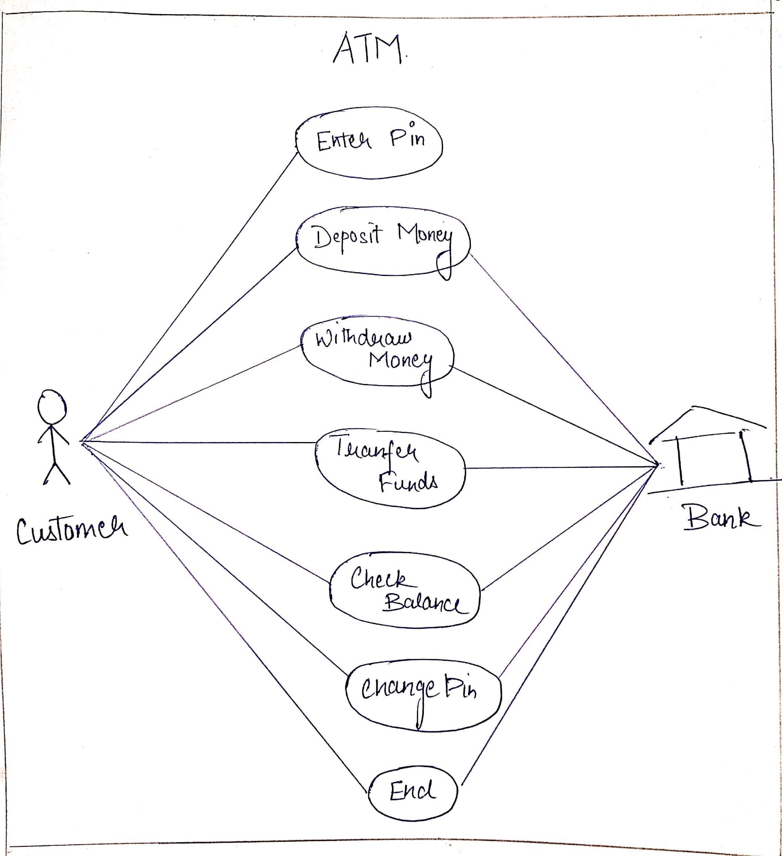

Fig.2.1

2.2 Class diagram 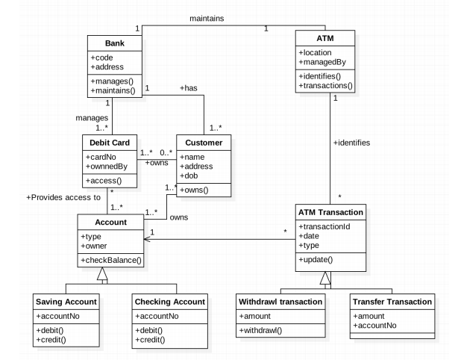

Fig 2.2

**2.3 Sequence Diagram**

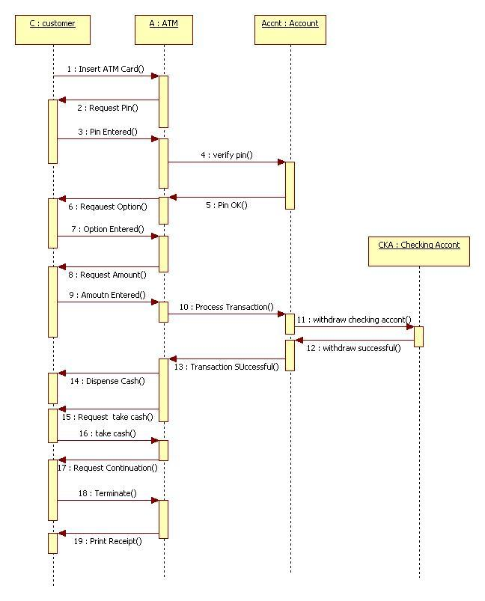

Fig 2.3

1. **Functionalities**
   1. Enter the pin.

Here the user is asked for the pin, if he enters an incorrect pin , theres a pop up that shows that its incorrect. After the right pin you enter the system.

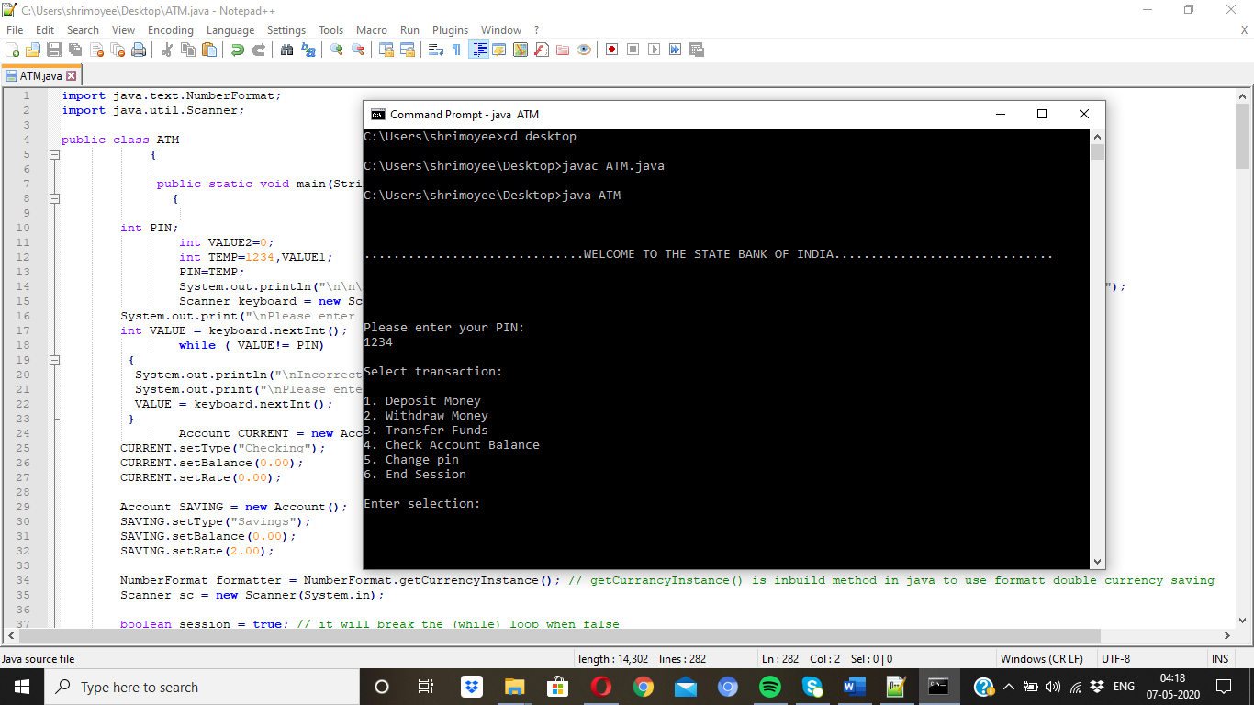

Fig.3.1

* 1. Deposit Money:

This helps the user to put money in their own account. We have put two options of savings and current account. The money can be deposited in any of the two accounts. Then it also prints how much money the user has in his/her account.

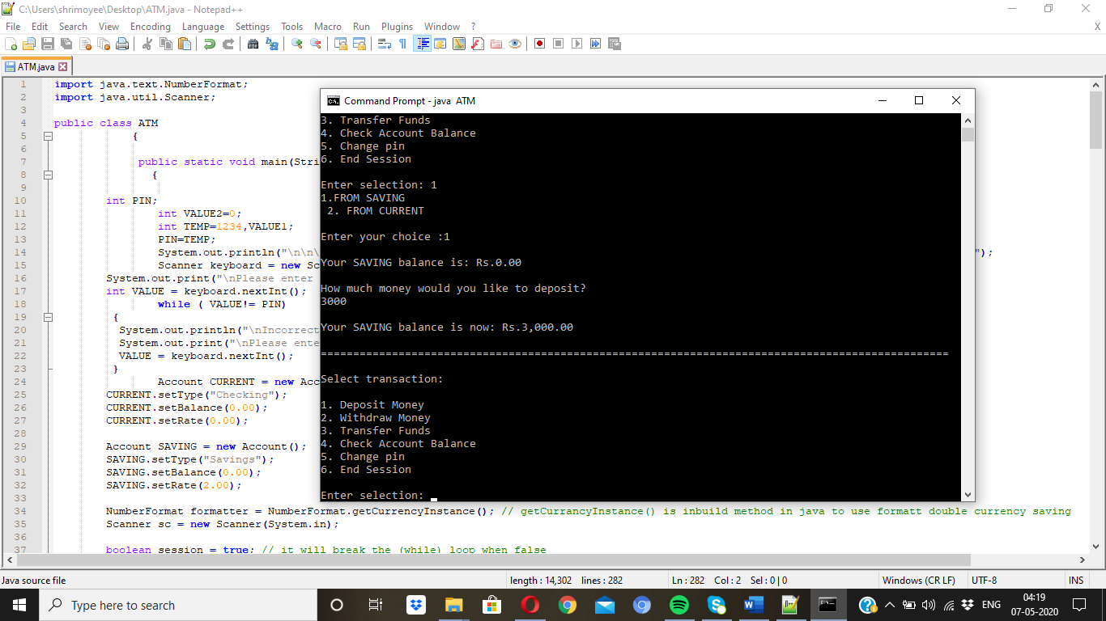

Fig.3.2

* 1. WITHDRAW MONEY:

This functionality helps the user to take out as much money as it has in his account. It also questions from which account it needs to be withdrawn. After the process is done, it also prints the money left.

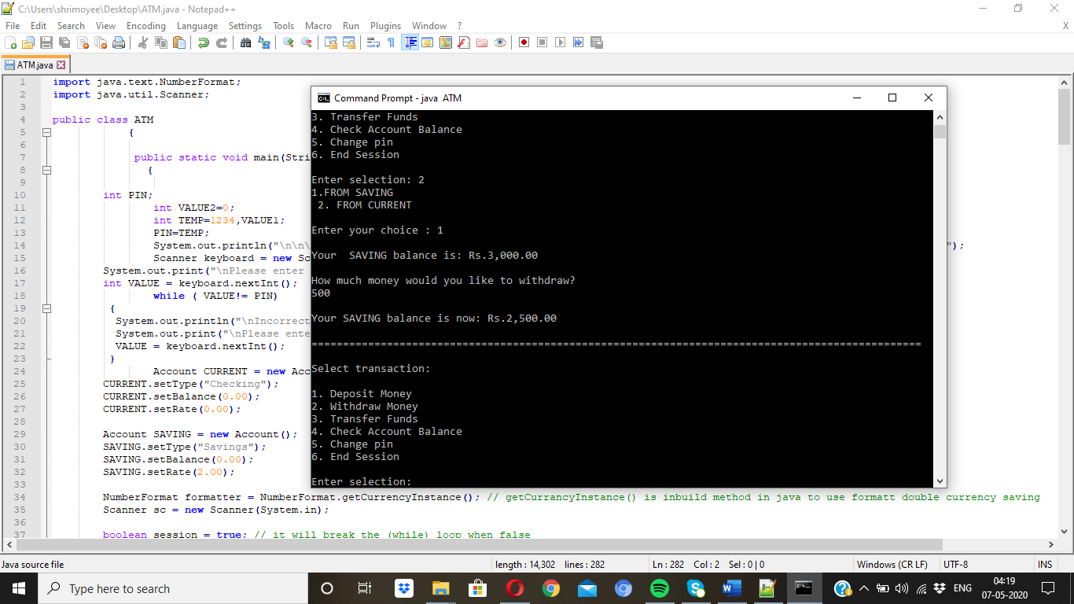

Fig. 3.3

* 1. TRANSFER FUNDS:

This allows the user to transfer its funds from savings to current account and vice versa. It also prints at the end.

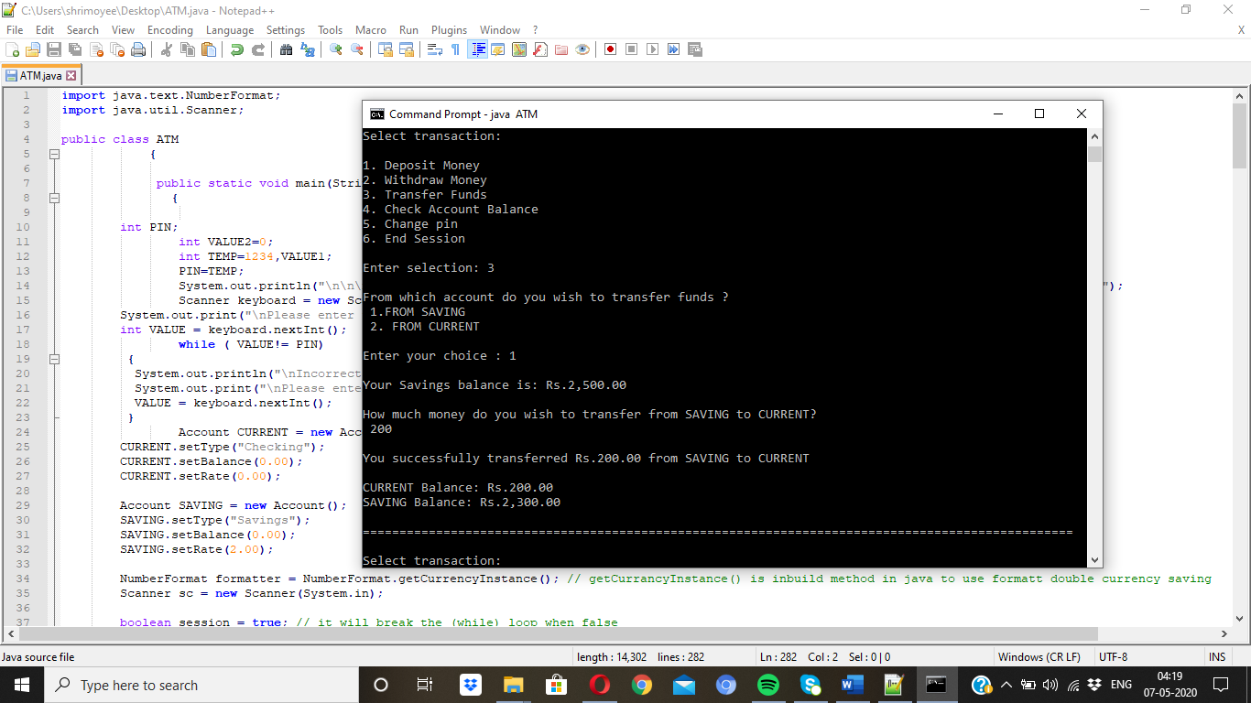

Fig 3.4

* 1. CHECK ACCOUNT BALANCE:

It checks the user’s balance in his/her account after all the transactions.

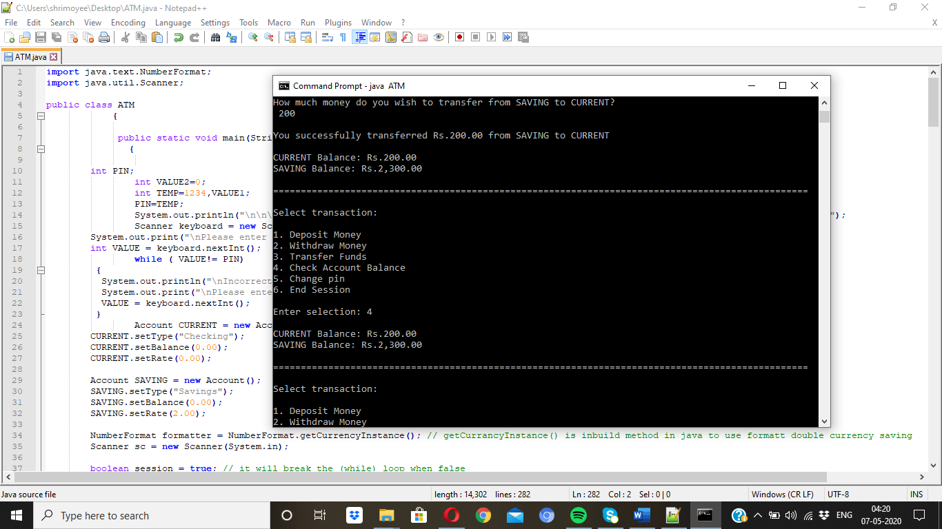fig 3.5

* 1. CHANGE PIN

This is if the user wants to change his/her pin they can . The user has to enter his old pin , if he enters it wrong theres a pop up saying “incorrect”. After the correct entering of previous pin, you have to enter the new pin twice and only then it’ll be changed and theres a pop us saying “pin successfully changes”.

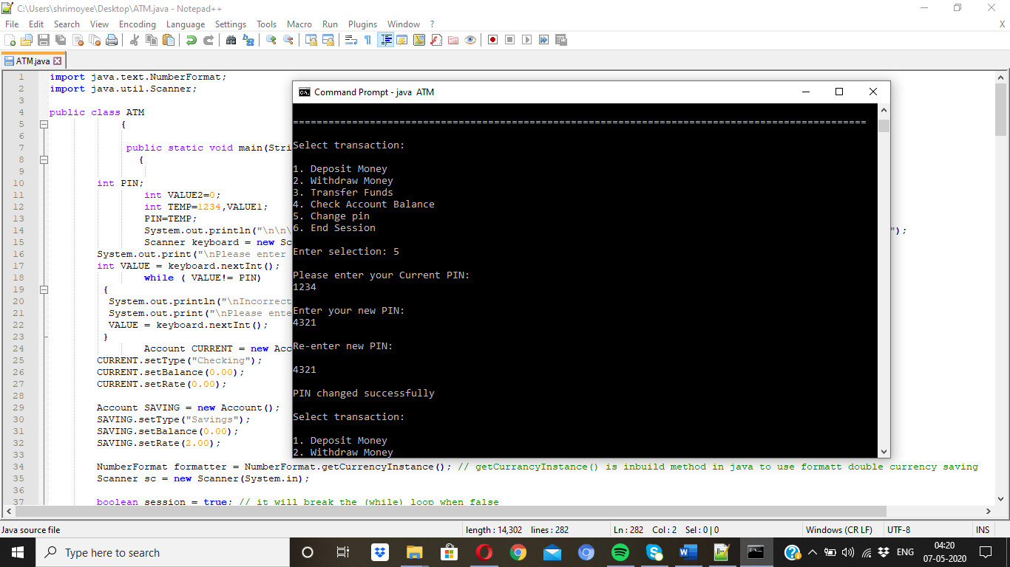

Fig 3.6

* 1. END SESSION

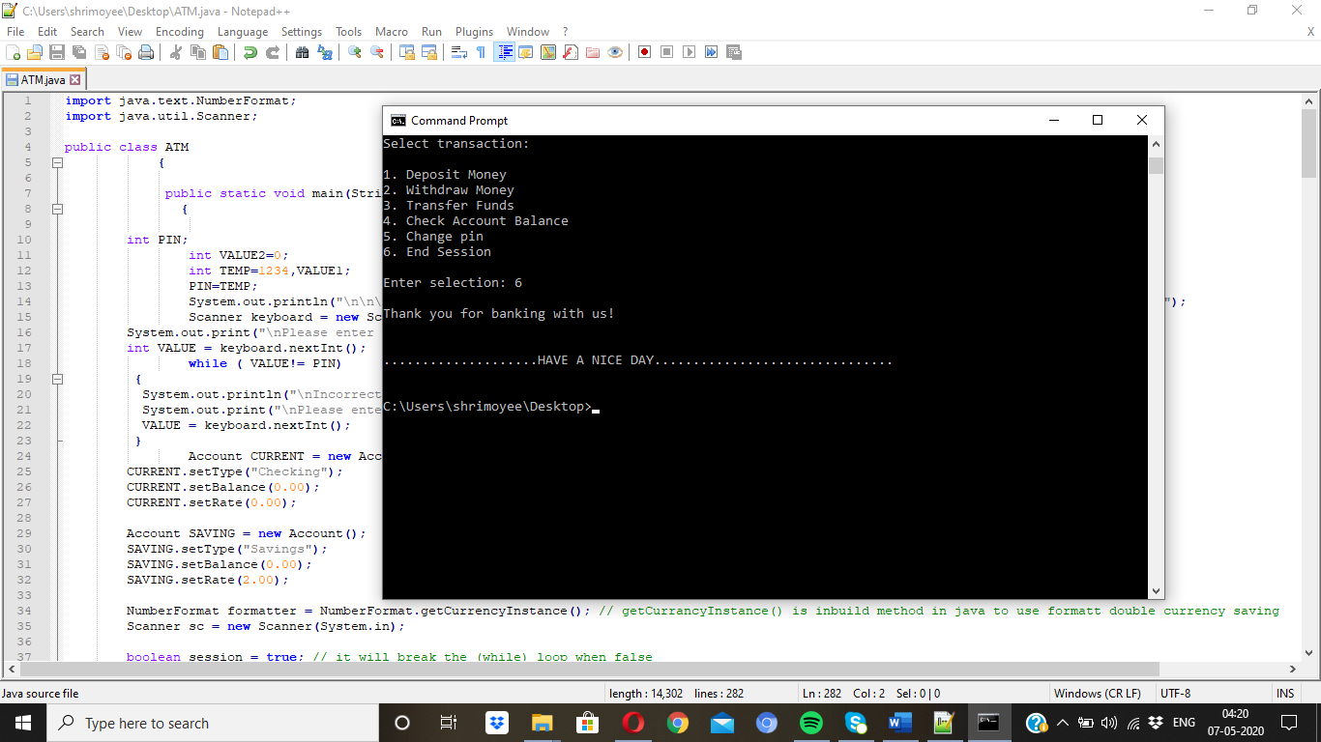

Fig 3.7

**F. SUMMARY AND CONCLUSION**

F.1 Summary

This report discussed our project’s functional requirements, the design process and its successful implementation. We briefly laid out the functioning of the program and how it makes the user’s life simpler money wise. How they do not need a third person for their transaction of money.

F.2 CONCLUSION

After successful completion of the project we learned to:

• Acquire practical knowledge of Java, command prompt Server for project development.

• Identify, analyze, formulate and handle programming projects with a comprehensive and systematic approach.

• Contribute as a team in development of technical projects.

• Develop effective communication skills for presentation of project related activities.

**References**

1. Herbert Schildt, Java Complete Reference, Tata McGraw-Hill Education

**Appendix A – List of Useful Websites**

1. For learning about the use case , class, sequence diagram –

<http://groups.umd.umich.edu/cis/course.des/cis375/active/class6/UML-ATM.pdf>

1. <https://www.slideshare.net/khalidbazgamah/atm-project-75361416>